第一步：

在原程序最前面增加如下代码：

option bit 32

AutoGate_COM_Port = 8

其中AutoGate_COM_Port为COM端口号

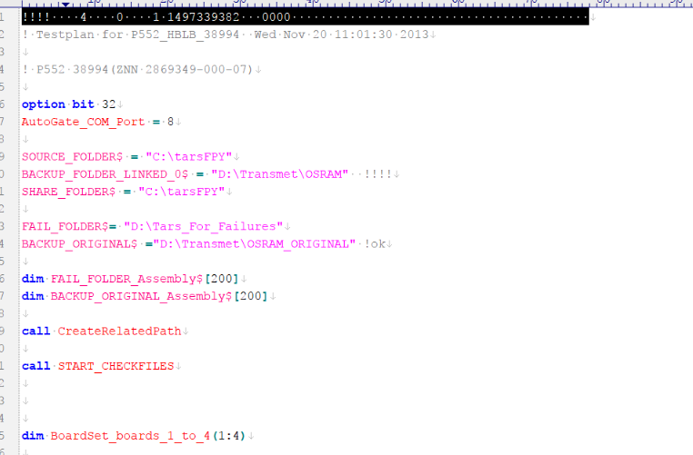

第二步：

在原程序最后面增加如下代码：

!-----------Auto Gate For OSRAM Ver 1.1----------------------

sub Close_door !! close door

global AutoGate_COM_Port

call Check_AutoGate_COM

assign @AutoGate to "/dev/com/"&val$(AutoGate_COM_Port)

control @AutoGate,3;oti("200062")

timeout @AutoGate,1

wait 500m

output @AutoGate; "close door"

wait 1.5

Retry = 1

loop

enter @AutoGate,,Err; Status$

if Status$[1;13] <> "close door_ok" then

Retry = Retry + 1

print tab(3);chr$(27)&"&v1S Retry:";Retry;"Remove object from safe sensor! ..."

wait 500m

if Retry = 20 then

print tab(3);chr$(27)&"&v1S Closed Gate Failed!"

stop

end if

end if

exit if Status$[1;13] = "close door_ok"

end loop

assign @AutoGate to *

subend

sub Open_door !! open door

global AutoGate_COM_Port

call Check_AutoGate_COM

assign @AutoGate to "/dev/com/"&val$(AutoGate_COM_Port)

control @AutoGate,3;oti("200062")

timeout @AutoGate,1

wait 500m

output @AutoGate; "open door"

wait 1.5

Retry = 1

loop

enter @AutoGate,,Err; Status$

if Status$[1;13] <> "open door_ok" then

Retry = Retry + 1

print tab(3);chr$(27)&"&v1S Retry:";Retry;"Remove object from safe sensor! ..."

wait 500m

if Retry = 20 then

print tab(3);chr$(27)&"&v1S Closed Gate Failed!"

stop

end if

end if

exit if Status$[1;12] = "open door_ok"

end loop

assign @AutoGate to *

subend

sub Check_AutoGate_COM

global AutoGate_COM_Port

Retry = 1

loop

Retry = Retry + 1

assign @AutoGate ,Err to "/dev/com/"&val$(AutoGate_COM_Port)

exit if Err = 0

if Retry = 20 then

print tab(3);chr$(27)&"&v1S Please check COM PORT!"

stop

end if

assign @AutoGate ,Err to *

wait 500m

end loop

subend

!-----------Auto Gate For OSRAM Ver 1.1----------------------

其中绿色部分为开盖和关盖后等待机械运动的延时。

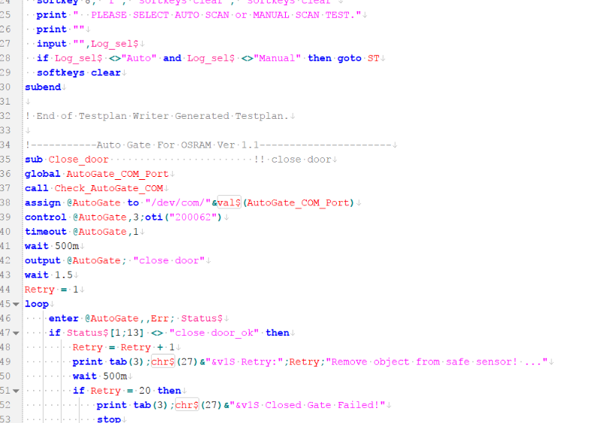

第三步：

自动扫描的情况下，在扫描前加入如下：

call Close_door | wait 1

手动扫描的情况下，在扫描后，下压前加入如下代码：

call Close_door | wait 1

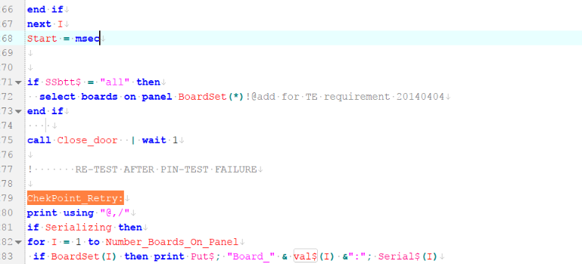

在夹具上升后加入如下代码：

call Open_door | wait 1

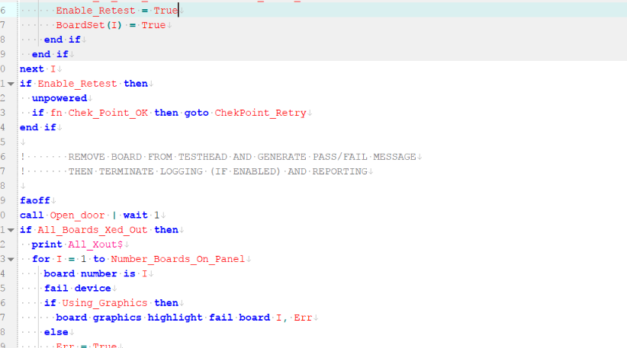

如下是示例和完整代码：

